Employee Skill Gap Analysis and Training Recommendation System
A CAPSTONE PROJECT REPORT
Submitted in the partial fulfilment for the Course of
CSA1012-Software Engineering
to the award of the degree of
BACHELOR OF ENGINEERING
In
Artificial intelligence and Data science
Submitted by
POOJA S(192524211)
Under the Supervision of
Dr. K. Anita Davamani


SIMATS ENGINEERING
Saveetha Institute of Medical and Technical Sciences
Chennai-602105
July-2026

INDEX
S. No. | Topic Name | Page No.
1 | Introduction | 3
2 | Project Vision and Stakeholders | 4
3 | Create Epics and User Stories | 10
4 | Define Acceptance Criteria | 14
5 | Prioritize the Product Backlog | 16
6 | Plan the Sprint Backlog | 19
7 | Estimate Effort Using Story Points | 22
9 | Overall Conclusion | 24
10 | References | 24

Introduction
Employee skills play a vital role in determining the overall productivity and success of an organization. As industries continue to adopt new technologies and business practices, employees are expected to acquire updated knowledge and competencies to perform their jobs effectively. However, many organizations face challenges in identifying the gap between the skills employees currently possess and the skills required for their job roles. Traditional methods of skill assessment are often manual, time-consuming, and prone to inaccuracies, making it difficult for Human Resource (HR) departments to plan effective employee development programs.
The Employee Skill Gap Analysis and Training Recommendation System is designed to overcome these challenges by providing an automated platform that evaluates employee competencies, compares them with predefined job requirements, and identifies areas where improvement is needed. Based on the identified skill gaps, the system recommends appropriate training programs that help employees enhance their knowledge and improve their overall performance.
The proposed system benefits employees, HR managers, team leaders, and organizational management by providing accurate skill assessments, personalized learning recommendations, and comprehensive reports. It supports continuous learning, workforce planning, and career development while reducing manual effort and improving decision-making. By adopting Agile Software Engineering practices, the system can be developed incrementally, ensuring flexibility, maintainability, and high-quality software that meets the evolving needs of modern organizations.

1. Project Vision and Stakeholders
1.1 Project Vision
Vision Statement
The vision of the Employee Skill Gap Analysis and Training Recommendation System is to develop an intelligent software platform that helps organizations evaluate employees' existing skills, identify gaps between current competencies and job requirements, and recommend personalized training programs. The system aims to improve employee performance, enhance workforce productivity, and support continuous professional development through data-driven skill assessment and learning recommendations.
The proposed system enables Human Resource (HR) managers and team leaders to monitor employee competencies, identify areas requiring improvement, and provide appropriate training opportunities. Employees can view their skill profiles, understand their strengths and weaknesses, and receive customized learning recommendations to enhance their career growth. By automating the skill assessment process, the system reduces manual effort, improves decision-making, and ensures that employees possess the necessary skills to meet organizational objectives.

1.2 Project Objectives
The objectives of the proposed system are:
- Maintain employee profiles and skill information.
- Assess employee skills based on predefined competency requirements.
- Identify skill gaps by comparing existing skills with required job skills.
- Recommend suitable training programs for skill improvement.
- Monitor employee learning progress and training completion.
- Generate detailed skill analysis reports for HR managers.
- Support workforce planning and employee career development.
- Improve organizational productivity through continuous skill enhancement.

1.3 Stakeholder Identification
Stakeholder | Role | Responsibilities
Employee | Primary User | Updates personal skills, views skill gaps, and completes recommended training programs.
HR Manager | Administrator | Manages employee records, performs skill assessments, and assigns training programs.
Team Leader | Supervisor | Reviews employee performance, monitors skill development, and recommends improvements.
Training Coordinator | Trainer | Creates, manages, and schedules training programs for employees.
System Administrator | System Manager | Maintains the system, manages users, databases, and ensures system security.
Company Management | Decision Maker | Reviews organizational skill reports and plans workforce development strategies.

1.4 Stakeholder Relationship Diagram
Figure 1.1 Stakeholder Relationship Diagram
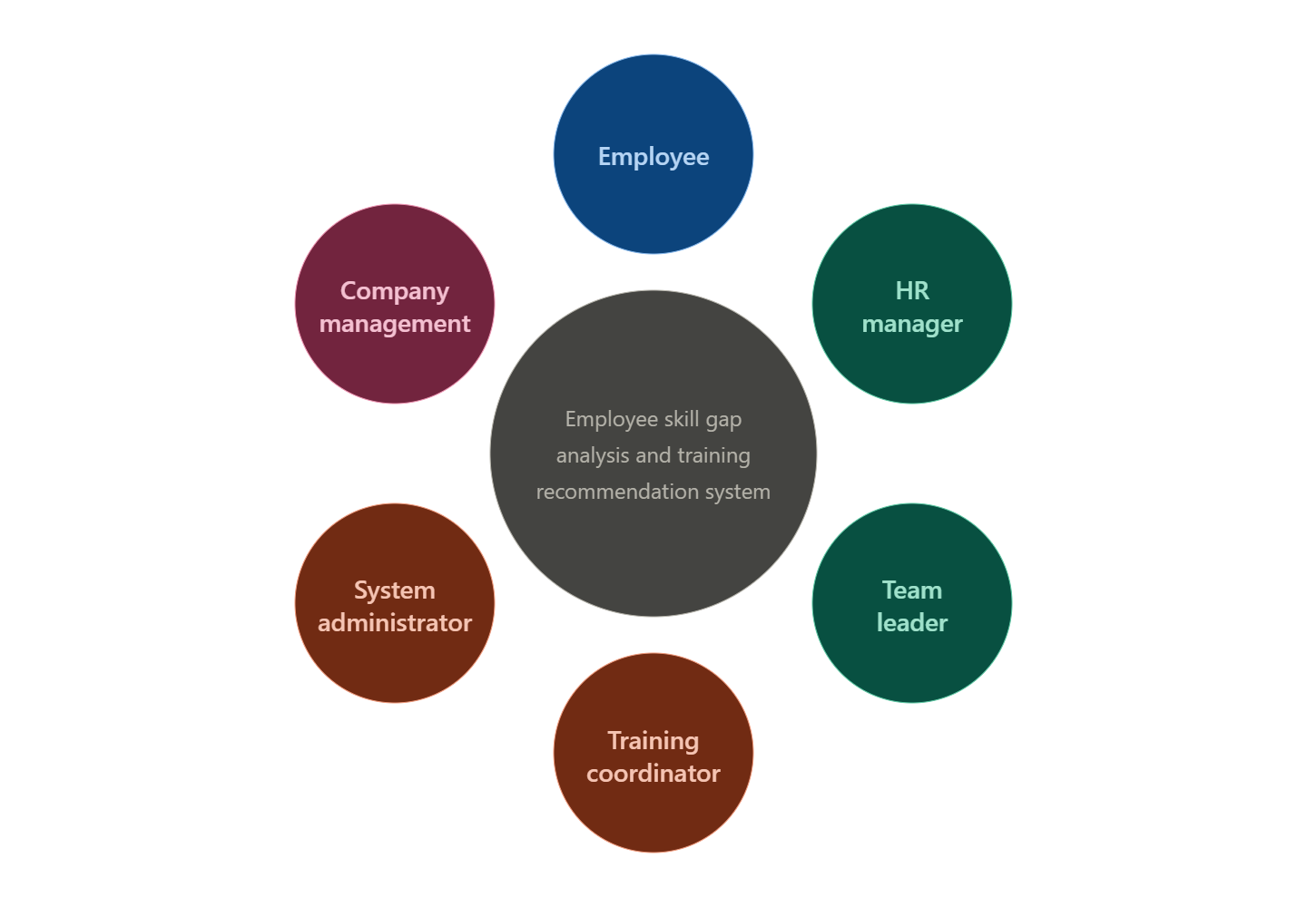

1.5 Summary
The proposed Employee Skill Gap Analysis and Training Recommendation System provides an efficient and structured platform for evaluating employee competencies and recommending suitable training programs. By identifying skill gaps and offering personalized learning opportunities, the system helps employees improve their professional skills while enabling organizations to build a highly skilled workforce. The platform supports better decision-making, enhances employee performance, and contributes to the long-term growth and success of the organization.
2. Create Epics and User Stories
2.1 Introduction
In Agile Software Engineering, an Epic represents a major functional area of the system, while User Stories describe specific requirements from the perspective of end users. Dividing the project into Epics and User Stories helps the development team understand business requirements, prioritize features, and deliver software incrementally during each sprint.
For the proposed Employee Skill Gap Analysis and Training Recommendation System, the project is divided into six major Epics. Each Epic contains multiple User Stories that focus on delivering value to employees, HR managers, team leaders, and organizational management.
2.2 Epic Identification
Epic ID | Epic Name | Description
EP-01 | Employee Management | Enables employees and HR managers to register, manage, and update employee profiles and personal information.
EP-02 | Skill Assessment | Records employee skills, evaluates competencies, and maintains skill information.
EP-03 | Skill Gap Analysis | Compares employee skills with required job competencies and identifies missing skills.
EP-04 | Training Recommendation | Recommends personalized training courses based on identified skill gaps.
EP-05 | Progress Tracking | Tracks employee training completion, certifications, and skill improvement.
EP-06 | Reports & Dashboard | Displays reports, analytics, and dashboards for HR managers and company management.

2.3 User Stories
Epic EP-01: Employee Management
User Story ID | User Story
US-01 | As an HR Manager, I want to register a new employee so that employee information can be stored securely.
US-02 | As an employee, I want to update my personal profile so that my information remains accurate and up to date.
US-03 | As an HR Manager, I want to search employee records so that I can easily access employee information.

Epic EP-02: Skill Assessment
User Story ID | User Story
US-04 | As an employee, I want to update my technical and professional skills so that my skill profile remains current.
US-05 | As an HR Manager, I want to evaluate employee skills so that employee competencies can be assessed accurately.

Epic EP-03: Skill Gap Analysis
User Story ID | User Story
US-06 | As an HR Manager, I want the system to compare employee skills with job requirements so that skill gaps can be identified automatically.
US-07 | As a Team Leader, I want to view employee skill gap reports so that I can plan employee development activities.

Epic EP-04: Training Recommendation
User Story ID | User Story
US-08 | As an employee, I want personalized training recommendations so that I can improve my missing skills.
US-09 | As an HR Manager, I want to assign training programs so that employees can develop the required competencies.

Epic EP-05: Progress Tracking
User Story ID | User Story
US-10 | As an employee, I want to track my training progress so that I know my learning status and completed courses.
US-11 | As a Team Leader, I want to monitor employee learning progress so that I can evaluate performance improvement.

Epic EP-06: Reports & Dashboard
User Story ID | User Story
US-12 | As an HR Manager, I want to generate skill gap reports so that I can analyze employee competencies.
US-13 | As Company Management, I want to view dashboards and analytics so that I can make informed workforce planning decisions.

2.4 Epic and User Story Relationship
Figure 2.1 Epic and User Story Relationship
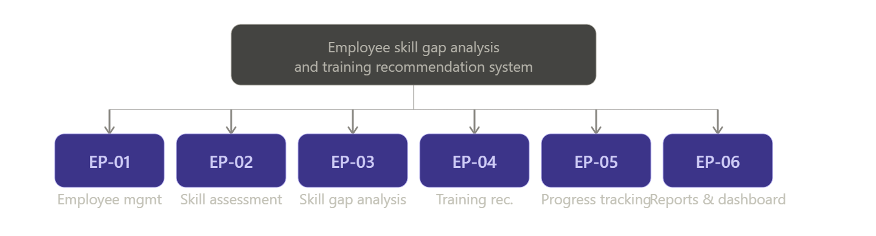2.5 Summary
The identified Epics and User Stories define the major functional requirements of the Employee Skill Gap Analysis and Training Recommendation System. Each User Story focuses on a specific user need and supports incremental software development using Agile Sprint Planning. This structured approach improves communication among stakeholders, simplifies requirement management, and ensures the development team delivers valuable features in every sprint.
3. Define Acceptance Criteria
3.1 Introduction
Acceptance Criteria are the conditions that must be satisfied before a User Story is considered complete. They help developers, testers, and stakeholders understand the expected behavior of the system and verify whether the implemented feature meets business requirements. In Agile Software Engineering, Acceptance Criteria are commonly written using the Given–When–Then format to make requirements clear, measurable, and testable.
For the proposed Employee Skill Gap Analysis and Training Recommendation System, the following Acceptance Criteria ensure that each feature functions correctly and meets stakeholder expectations.
3.2 Acceptance Criteria
User Story ID | Acceptance Criteria (Given – When – Then)
US-01 | Given the HR Manager is on the employee registration page, When valid employee details are entered and the Register button is clicked, Then the employee record should be created successfully.
US-02 | Given an employee is logged into the system, When the employee updates personal profile information, Then the changes should be saved successfully.
US-03 | Given employee records exist in the system, When the HR Manager searches using an employee ID or name, Then the correct employee details should be displayed.
US-04 | Given an employee is logged in, When the employee updates technical or professional skills, Then the skill information should be stored successfully.
US-05 | Given employee skill records are available, When the HR Manager performs a skill assessment, Then the employee competency level should be displayed correctly.
US-06 | Given employee skills and job requirements are available, When the system performs skill gap analysis, Then the missing skills should be identified and displayed accurately.
US-07 | Given skill gap analysis has been completed, When the Team Leader views the report, Then the employee skill gap details should be displayed correctly.
US-08 | Given employee skill gaps are identified, When the employee views training recommendations, Then appropriate training courses should be displayed.
US-09 | Given training programs are available, When the HR Manager assigns a training program, Then the assigned training should appear in the employee dashboard.
US-10 | Given an employee has completed training, When the employee views learning progress, Then completed and pending courses should be displayed correctly.
US-11 | Given employees are undergoing training, When the Team Leader checks progress, Then employee completion status should be displayed.
US-12 | Given skill assessment data is available, When the HR Manager generates a report, Then the system should produce a complete skill gap report successfully.
US-13 | Given employee performance data is available, When Company Management views the dashboard, Then workforce analytics and skill statistics should be displayed accurately.

3.3 Benefits of Acceptance Criteria
- Clearly defines the expected behavior of each system feature.
- Reduces misunderstandings between developers and stakeholders.
- Ensures software requirements are measurable and testable.
- Improves software quality by validating every User Story before completion.
- Supports successful Sprint Review and Sprint Acceptance.
- Helps testers create effective test cases for system validation.
- Ensures the developed software satisfies business requirements.
3.4 Summary
The Acceptance Criteria defined for the selected User Stories ensure that every feature of the Employee Skill Gap Analysis and Training Recommendation System is measurable, testable, and aligned with stakeholder expectations. Using the Given–When–Then format improves communication among developers, testers, and stakeholders while ensuring reliable software delivery during every Agile sprint.
4. Prioritize the Product Backlog
4.1 Introduction
The Product Backlog is a prioritized list of all the features, enhancements, and requirements needed to develop the system. In Agile Software Development, the Product Owner prioritizes backlog items based on business value, stakeholder needs, project dependencies, and implementation complexity. High-priority features are developed first to ensure that the most valuable functionalities are delivered early in the project.
For the proposed Employee Skill Gap Analysis and Training Recommendation System, the Product Backlog focuses on essential features such as employee management, skill assessment, skill gap analysis, and training recommendations before implementing advanced reporting and analytics.
4.2 Product Backlog
Backlog ID | Feature / User Story | Priority | Business Value
PB-01 | Employee Registration | High | High
PB-02 | Employee Login | High | High
PB-03 | Employee Profile Management | High | High
PB-04 | Skill Assessment | High | High
PB-05 | Skill Gap Analysis | High | High
PB-06 | Training Recommendation | High | High
PB-07 | Training Assignment | Medium | Medium
PB-08 | Training Progress Tracking | Medium | Medium
PB-09 | Skill Gap Report Generation | Medium | Medium
PB-10 | Employee Dashboard | Medium | Medium
PB-11 | HR Dashboard & Analytics | Medium | Medium
PB-12 | Notification & Alerts | Low | Low
PB-13 | Certificate Management | Low | Low

4.3 Priority Classification
Priority Level | Description
High | Core features required for the first software release and essential system functionality.
Medium | Features that improve system usability, monitoring, and employee experience.
Low | Additional features and enhancements that can be implemented in future sprints.

4.4 Product Backlog Workflow
Figure 4.1 Product Backlog Prioritization Process
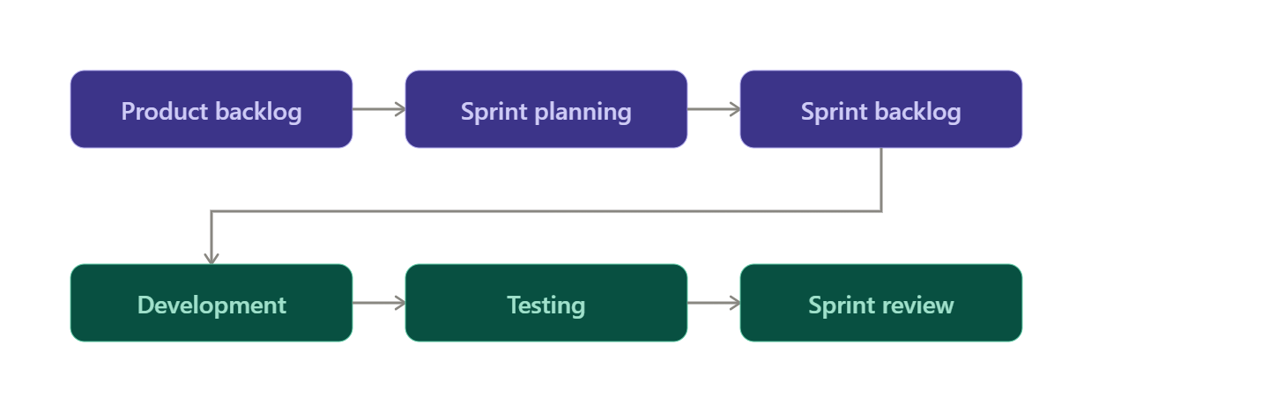
4.5 Summary
The Product Backlog organizes all project requirements according to their priority and business value. Prioritizing backlog items ensures that essential features such as employee registration, skill assessment, skill gap analysis, and training recommendations are completed first. This approach enables the development team to deliver a functional and valuable system incrementally while supporting continuous improvement in future Agile sprints.
5. Plan the Sprint Backlog
5.1 Introduction
A Sprint Backlog is a list of selected Product Backlog items that the development team commits to completing during a sprint. It contains the user stories, development tasks, assigned team members, and expected outcomes. The Sprint Backlog helps the Agile team organize work, monitor progress, and ensure timely delivery of software features.
For the proposed Employee Skill Gap Analysis and Training Recommendation System, the first sprint focuses on developing the core functionalities required to build a working prototype. These include employee management, skill assessment, skill gap analysis, and training recommendation features.

5.2 Sprint Details
Sprint Attribute | Details
Sprint Name | Sprint 1
Sprint Duration | 2 Weeks
Sprint Goal | Develop the core features of the Employee Skill Gap Analysis and Training Recommendation System
Team Size | 5 Members

5.3 Sprint Backlog
Task ID | Task | Assigned To | Status
T1 | Design Employee Registration Page | Frontend Developer | To Do
T2 | Develop Login & Authentication Module | Backend Developer | To Do
T3 | Develop Employee Skill Assessment Module | Backend Developer | To Do
T4 | Implement Skill Gap Analysis Module | Full Stack Developer | To Do
T5 | Develop Training Recommendation Module | Full Stack Developer | To Do
T6 | Create Employee & HR Dashboard | Frontend Developer | To Do
T7 | Testing and Bug Fixing | QA Tester | To Do

5.4 Sprint Task Board (Kanban Board)
To Do | In Progress | Testing | Done
Employee Registration | Skill Assessment Module | Dashboard Testing | -
Login Module | Skill Gap Analysis | Training Module | -
Employee Dashboard | Training Recommendation | Bug Fixing | -
Report Generation | Profile Management | Integration Testing | -

5.5 Expected Sprint Outcome
At the end of Sprint 1, the development team is expected to deliver:
- Employee Registration and Login functionality.
- Employee Skill Assessment module.
- Skill Gap Analysis feature.
- Personalized Training Recommendation module.
- Employee and HR Dashboard.
- Initial testing and bug fixes.
These deliverables will form the first working version (Minimum Viable Product - MVP) of the Employee Skill Gap Analysis and Training Recommendation System.
5.6 Summary
The Sprint Backlog defines the work planned for the first sprint and assigns responsibilities to the development team. Proper sprint planning improves collaboration, tracks progress efficiently, and ensures that the team delivers a functional software increment within the planned sprint duration. Completing these core modules establishes a strong foundation for future enhancements, including advanced analytics, reporting, and employee performance monitoring.
6. Estimate Effort Using Story Points
6.1 Introduction
Story Points are used in Agile Software Development to estimate the effort required to complete a User Story. Instead of measuring work in hours, Story Points estimate the complexity, amount of work, uncertainty, and risk involved in implementing a feature. The Fibonacci sequence (1, 2, 3, 5, 8, 13) is commonly used because it reflects the increasing uncertainty of larger tasks.
For the proposed Employee Skill Gap Analysis and Training Recommendation System, Story Points are assigned based on the complexity of each User Story and the development effort required.
6.2 Story Point Estimation
User Story ID | User Story | Story Points
US-01 | Employee Registration | 3
US-02 | Update Employee Profile | 2
US-03 | Search Employee Records | 3
US-04 | Update Employee Skills | 5
US-05 | Skill Assessment | 8
US-06 | Skill Gap Analysis | 8
US-07 | View Skill Gap Report | 5
US-08 | Training Recommendation | 8
US-09 | Assign Training Program | 5
US-10 | Track Training Progress | 5
US-11 | Monitor Employee Progress | 3
US-12 | Generate Skill Gap Reports | 5
US-13 | Dashboard & Analytics | 8

6.3 Story Point Scale
Story Points | Effort Level
1–2 | Very Low
3 | Low
5 | Medium
8 | High
13 | Very High

Figure 6.1 Story Point Estimation Scale
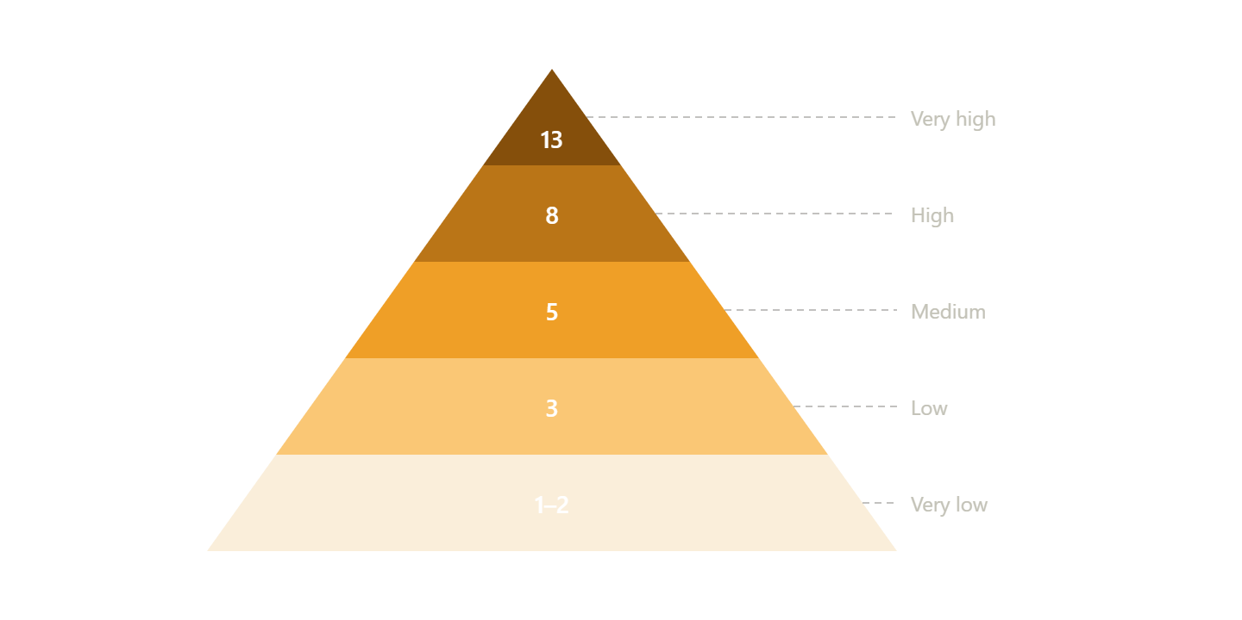

6.4 Summary
Story Point Estimation helps the Agile team understand the effort required to complete each User Story and supports effective sprint planning. High-complexity tasks such as Skill Assessment, Skill Gap Analysis, Training Recommendation, and Dashboard Development are assigned higher Story Points because they involve complex business logic, data processing, and system integration. Lower-complexity tasks such as employee registration, profile management, and progress monitoring require less development effort and are assigned fewer Story Points. Proper estimation improves sprint planning, workload distribution, and timely project delivery.
7. Present the Sprint Goal and Expected Deliverables
7.1 Sprint Goal
The primary goal of Sprint 1 is to develop a functional prototype of the Employee Skill Gap Analysis and Training Recommendation System by implementing the core features required for employee skill management and training support. The sprint focuses on developing a secure employee management system, assessing employee skills, identifying skill gaps, recommending suitable training programs, and providing interactive dashboards for HR managers and employees.
The sprint also aims to ensure that the implemented features are tested, reliable, and ready for stakeholder review. By the end of the sprint, the team will deliver a Minimum Viable Product (MVP) that demonstrates the essential functionalities of the proposed system.

7.2 Expected Deliverables
Deliverable | Description
Employee Registration & Login | Secure employee registration, login, and profile management functionality.
Skill Assessment Module | Allows employees to update their skills and enables HR to assess employee competencies.
Skill Gap Analysis | Compares employee skills with job requirements and identifies missing competencies.
Training Recommendation Module | Recommends suitable training courses based on identified skill gaps.
Employee & HR Dashboard | Displays employee skill profiles, training progress, reports, and analytics.
Testing Report | Verifies system functionality, fixes defects, and ensures quality before deployment.

7.3 Sprint Deliverables Workflow
Figure 7.1 Sprint Goal and Deliverables Workflow
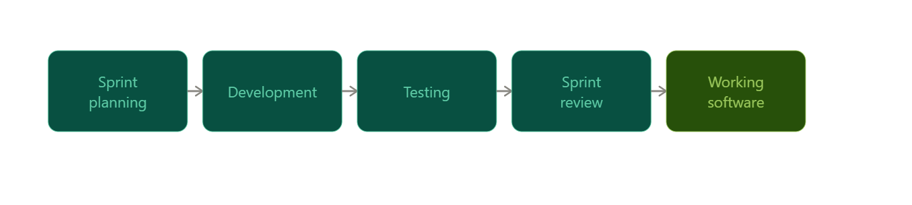
7.4 Summary
The successful completion of Sprint 1 will deliver a working prototype of the Employee Skill Gap Analysis and Training Recommendation System with its essential functionalities. The developed modules will enable employee registration, skill assessment, skill gap identification, training recommendation, and dashboard reporting. These deliverables provide a strong foundation for future enhancements, such as AI-based skill prediction, advanced analytics, certification tracking, and performance evaluation, while ensuring that Agile Software Development practices are followed throughout the project.
Overall Conclusion
The Employee Skill Gap Analysis and Training Recommendation System provides an effective solution for organizations to assess employee competencies, identify skill gaps, and recommend personalized training programs. By implementing Agile Software Engineering practices such as Project Vision, Epics, User Stories, Acceptance Criteria, Product Backlog, Sprint Backlog, Story Point Estimation, and Sprint Planning, the project is well-structured and easier to manage throughout its development lifecycle.
The proposed system enables HR managers, team leaders, and employees to work together in improving workforce skills through continuous learning and data-driven decision-making. It enhances employee productivity, supports career development, and assists organizations in building a highly skilled workforce capable of meeting evolving business requirements. Overall, the project demonstrates how Agile methodologies can successfully deliver a scalable, maintainable, and user-centric software solution.

References
- Roger S. Pressman & Bruce R. Maxim, Software Engineering: A Practitioner's Approach, 9th Edition, McGraw-Hill Education, 2020.
- Kenneth S. Rubin, Essential Scrum: A Practical Guide to the Most Popular Agile Process, Addison-Wesley Professional, 2012.
- Ian Sommerville, Software Engineering, 10th Edition, Pearson Education, 2016.
- Agile Alliance. Agile 101 – Agile Principles and Practices. https://agilealliance.org/agile101/

